BCMS Incident Management iPhone Application Portrait Prototype Conversion Assembly Deployment Guide

Revision History
Author | Revision Number | Date
subchap | 1.1 | Nov. 15, 2011
subchap | 1.0 | Nov. 3, 2011

Contents
Deployment Instructions 3
1. Organization of Submission 3
2. Environment Requirement 3
3. Application Configuration 3
4. Starting 4
5. Verification 4
6. Resource Contact List 8

Deployment Instructions

Organization of Submission
./src The source code folder.
./docs The documentation folder.

Environment Requirement
Mac OS X 10.6.8 or above
XCode 4.2
iOS 4.x or 5.0

Application Configuration
3.1 The configuration file is ‘DataSource.plist’ in ‘resources/Data/’ folder:

Property Key Path | Content
Data.userinfo | The user account information. It contains username and password.
Data.menu.userInfo | The user information.
Data.menu.items | The menu items. Each item has title, icon, and icon_highlighted fields.
Data.incidents | The incidents information.
Data.incidents.items | The incident items. Each item has status, incident_status, location, address, date, description, title, number, type, category, owner, department, notes, comments, outages. The notes is a list of notes, each of which has a details field. The comments is a list of comments, each of which has a details field.
Data.incidents.addNew | The form elements in the Add New Incidents View. Each item represents a group. Each item has showHeader, and items, each of which has title, type, default, offset, required.
Data.incidents.detailsForm | The form elements in the incidents details view. Each item represents a group. Each item is a dictionary with showHeader , header, and items. Each item has name and title and type elements.
Data.incidents.updateForm | The form elements in the update incidents view. Each item represents a group. Each item is a dictionary with showHeader , header, and items. Each item has name and title and type elements.
Data.incidents.checklistForm | The form elements in the update incidents view. Each item has title and items, each of which is a check item.
Data.filterSortOptions.items | The form items in the filter and sort options view. Each item has type, title and options. Options is an array with name and selected fields.
Data.contacts | An array with contacts information. Each contact item has name and items, each of which has name, acronym, and items (with name, title, and details elements).
Data.more | An array with More information. Each item has name and items, each of which has name and people (with name, occupation, primary, secondary elements).
Data.settings | An array with Settings information. Each item has name and items, each of which has name, title and details.
Data.conveneRooms | An array with Convene Rooms information. Each item has name and office elements.

Starting
4.1 Double click the ‘IncidentManagementApp.xcodeproj’ file, and choose the correct scheme (iPhone 4.x or 5.0 Simulator or device).
4.2 Then click “Run” to start the app.

Verification
5.1 Start the app and you will see the login screen. Enter demo/demo as the username/password and then click LOGIN to continue.
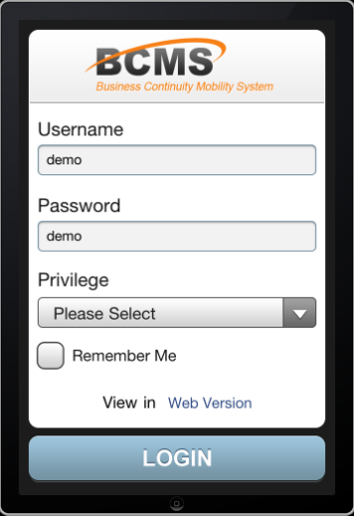

5.2 Then you will see the menu list:
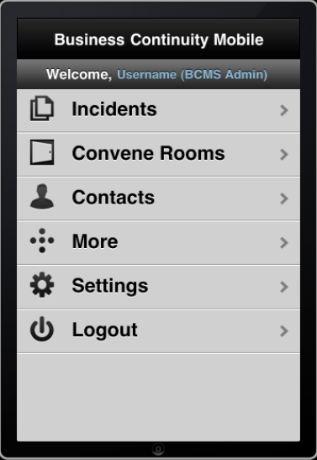

5.3 If you click Incidents in the menu list, you will go to the Incidents List view:

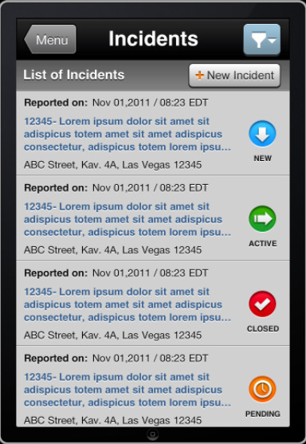

5.4 If you click “Convene Rooms” in the menu list, you will go to the convene rooms list:
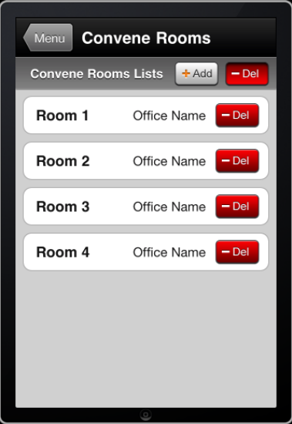

5.5 If you click “Contacts” in the menu list, you will go to the contacts view:
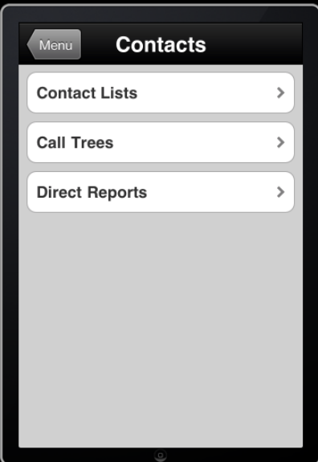
5.6 If you click “More” in the menu list, you will go to the More view:
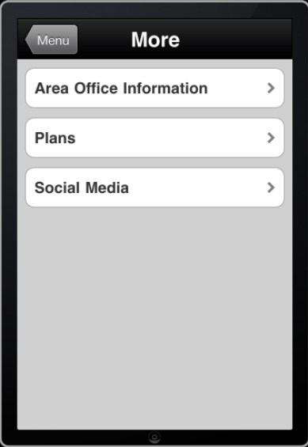

5.7 If you click “Settings” in the menu list, you will go to the Settings view:
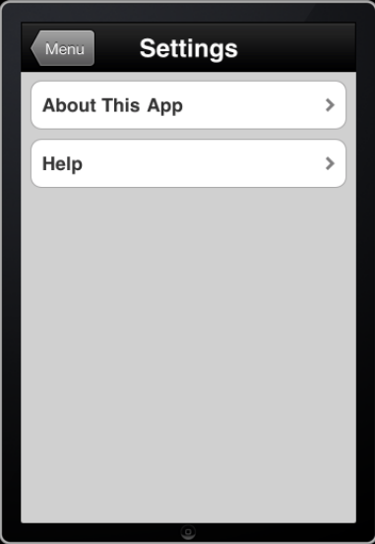

Resource Contact List
Name | Resource Email
subchap
subchap | Subchap2@gmail.com

